Attached are the data of Professor Luis Cardoso, Adjunct Professor at the Department of Language and Communication Sciences at the School of Education and Social Sciences of the Polytechnic Institute of Portalegre, Portugal

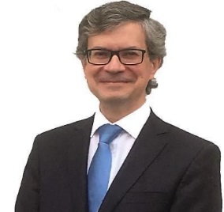
email: lmcardoso@ipportalegre.pt
phone: +351961851192
Luís Miguel Cardoso holds a PhD in Modern Languages and Literatures, in the speciality of Comparative Literature (Literature and Cinema), from the Faculty of Letters of the University of Coimbra. Adjunct Professor at the Department of Language and Communication Sciences at the School of Education and Social Sciences of the Polytechnic Institute of Portalegre, Portugal, he is a professor of Higher Education since 1995.
He was Dean of the School of Education and Social Sciences between 2010 and 2018 and Deputy Director of the Master in Media and Society. He is a researcher at the Center for Comparative Studies at the University of Lisbon.
He was President of ARIPESE, Association of Reflection and Intervention in the Educational Policy of Higher Education Schools in Portugal (2015 – 2018).
He was the Coordinator of the Communication Bureau of the Polytechnic Institute of Portalegre (2013 – 2017).
His main areas of teaching and research are Sciences of Language and Communication, Pedagogical Innovation, Literacies, Education, and Literature and Cinema, under which published scientific articles and made presentations, in Portugal and several countries, including Brasil, Spain, France, UK, Italy, Greece, Hungary, Bulgaria, Thailand, Turkey, Colombia, Indonesia, Ukraine, Pakistan, UAE and India. In 2016, he published the book Literature and Cinema. The Look Of Janus. Vergílio Ferreira and the space of the unspeakable, by Editions 70, Portugal.
He is a member of several international organizations and associations, as well as a member of the editorial board of international journals in the areas of Language and Communication Sciences, Comparative Literature, Literature and Cinema, Literacies and Education.
Please, inform the professor Luis as soon as his name is posted on the web of the magazine as a member of the Board.

